**Sample Sequence Diagrams generated from VS 2010**

Prepared By: Meyer Tanuan

Date: March 22, 2010

**Important: The sample sequence diagram does not imply that this is the best design for all projects.**

**Preparation Steps:**

1. Download and unzip Eisk 2.2.0.1 - VSTS 2008 Edition project (Employee Info Starter Kit URL: <http://code.msdn.microsoft.com/eisk> ). For details, see Systems Project Deployment Document: INFO3800_DeploymentGuide.doc
2. Start VS 2010
3. Open the VS 2008 solution file (**e-i-s-k-2008.sln** under **solution** folder)
4. Under Eisk.Library, open cl.EmployeeCL.cs
5. Select CRUD methods and generate Sequence Diagram

**Steps to generate Sequence Diagram:**

* Find “**SelectAllEmployees**”
* Right-click (result: context menu appears)
* Select Generate Sequence Diagram…
* Set maximum call depth to 10
* Click OK

**Sample SD for SelectAllEmployees()**

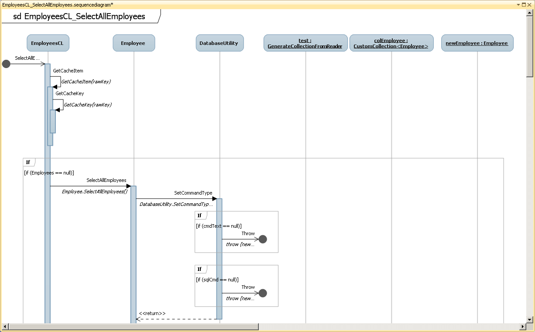

**Design Note**: EmployeeCL belongs to Cache Layer, Employee from Domain Layer, and DatabaseUtility from Data Access Layer. This design uses a separate Cache Layer and a generic DatabaseUtility class which encapsulates all the DataAccess Layer logic.

**Sample SD for GetEmployeeByEmployeeId()**

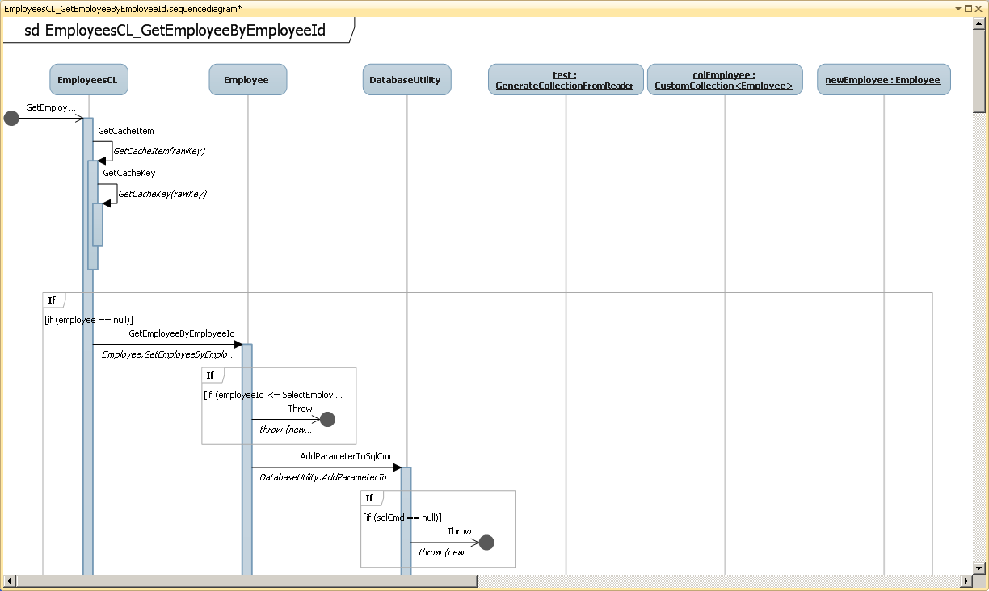

**Sample SD for CreateNewEmployee()**

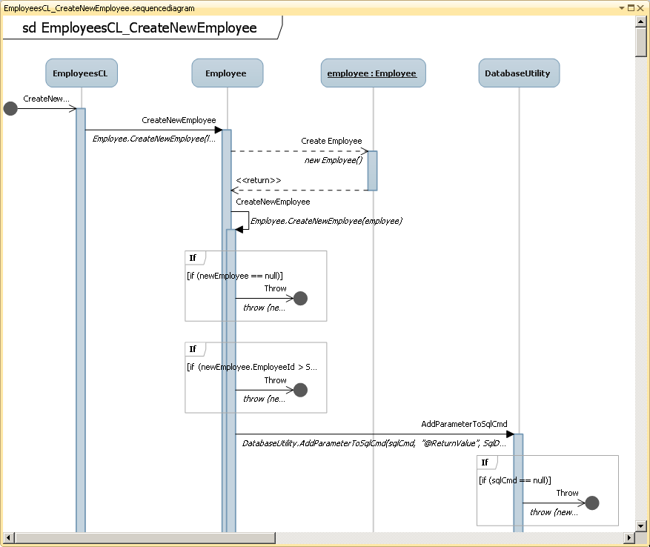

**Sample SD for UpdateEmployee()**

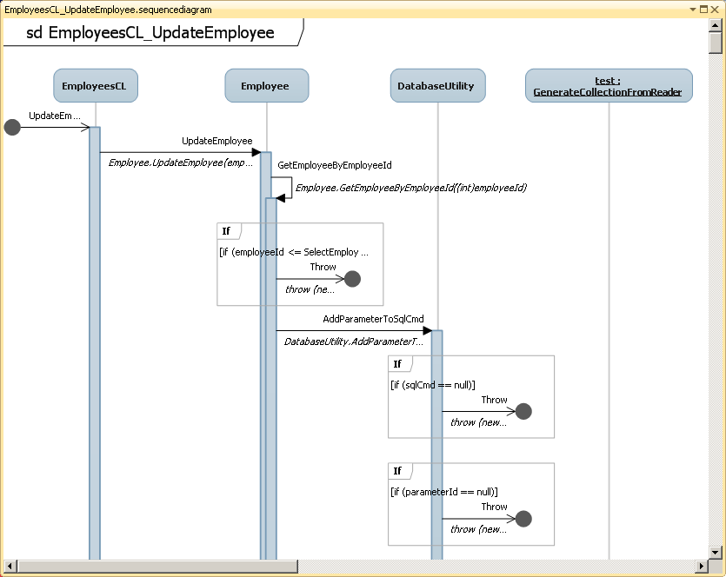

**Sample SD for DeleteEmployee()**

